**Question:**

1. **Create A Mobile Application For Taking Asurvey From The Customers/Users.**
2. **Present The Survey Results Using Custom Adapters**
3. **Test The Survey Application (Javacode) With Junit 5 In Androidstudio**

**Activity_main.xml**

*<?***xml version="1.0" encoding="utf-8"***?>*<**androidx.constraintlayout.widget.ConstraintLayout xmlns:android="http://schemas.android.com/apk/res/android"  
 xmlns:app="http://schemas.android.com/apk/res-auto"  
 xmlns:tools="http://schemas.android.com/tools"  
 android:layout_width="match_parent"  
 android:layout_height="match_parent"  
 tools:context=".MainActivity"**>  
  
 <**TextView  
 android:id="@+id/college_survey"  
 android:layout_width="wrap_content"  
 android:layout_height="wrap_content"  
 android:layout_centerHorizontal="true"  
 android:layout_marginBottom="656dp"  
 android:elevation="120dp"  
 android:text="College Survey"  
 android:textColor="@color/black"  
 android:textSize="30dp"  
 android:textStyle="bold"  
 app:layout_constraintBottom_toBottomOf="parent"  
 app:layout_constraintEnd_toEndOf="parent"  
 app:layout_constraintHorizontal_bias="0.497"  
 app:layout_constraintStart_toStartOf="parent"** />  
  
 <**EditText  
 android:id="@+id/editTextTextPersonName"  
 android:layout_width="324dp"  
 android:layout_height="55dp"  
 android:ems="10"  
 android:hint="Name"  
 android:inputType="textPersonName"  
 app:layout_constraintBottom_toBottomOf="parent"  
 app:layout_constraintEnd_toEndOf="parent"  
 app:layout_constraintHorizontal_bias="0.494"  
 app:layout_constraintStart_toStartOf="parent"  
 app:layout_constraintTop_toTopOf="parent"  
 app:layout_constraintVertical_bias="0.187"** />  
  
 <**EditText  
 android:id="@+id/editTextNumber"  
 android:layout_width="328dp"  
 android:layout_height="51dp"  
 android:ems="10"  
 android:hint="Age"  
 android:inputType="number"  
 app:layout_constraintBottom_toBottomOf="parent"  
 app:layout_constraintEnd_toEndOf="parent"  
 app:layout_constraintHorizontal_bias="0.518"  
 app:layout_constraintStart_toStartOf="parent"  
 app:layout_constraintTop_toTopOf="parent"  
 app:layout_constraintVertical_bias="0.301"** />  
  
 <**Button  
 android:id="@+id/button"  
 android:layout_width="wrap_content"  
 android:layout_height="wrap_content"  
 android:text="Submit"  
 app:layout_constraintBottom_toBottomOf="parent"  
 app:layout_constraintEnd_toEndOf="parent"  
 app:layout_constraintHorizontal_bias="0.784"  
 app:layout_constraintStart_toStartOf="parent"  
 app:layout_constraintTop_toTopOf="parent"  
 app:layout_constraintVertical_bias="0.913"** />  
  
 <**EditText  
 android:id="@+id/editTextTextPersonName2"  
 android:layout_width="325dp"  
 android:layout_height="54dp"  
 android:ems="10"  
 android:hint="College Name"  
 android:inputType="textPersonName"  
 app:layout_constraintBottom_toBottomOf="parent"  
 app:layout_constraintEnd_toEndOf="parent"  
 app:layout_constraintStart_toStartOf="parent"  
 app:layout_constraintTop_toTopOf="parent"  
 app:layout_constraintVertical_bias="0.412"** />  
  
 <**EditText  
 android:id="@+id/editTextTextPersonName3"  
 android:layout_width="324dp"  
 android:layout_height="51dp"  
 android:ems="10"  
 android:hint="Degree"  
 android:inputType="textPersonName"  
 app:layout_constraintBottom_toBottomOf="parent"  
 app:layout_constraintEnd_toEndOf="parent"  
 app:layout_constraintStart_toStartOf="parent"  
 app:layout_constraintTop_toTopOf="parent"  
 app:layout_constraintVertical_bias="0.516"** />  
  
 <**CheckBox  
 android:id="@+id/checkBox"  
 android:layout_width="wrap_content"  
 android:layout_height="wrap_content"  
 android:text="Yes"  
 app:layout_constraintBottom_toBottomOf="parent"  
 app:layout_constraintEnd_toEndOf="parent"  
 app:layout_constraintHorizontal_bias="0.289"  
 app:layout_constraintStart_toStartOf="parent"  
 app:layout_constraintTop_toTopOf="parent"  
 app:layout_constraintVertical_bias="0.67"** />  
  
 <**CheckBox  
 android:id="@+id/checkBox2"  
 android:layout_width="wrap_content"  
 android:layout_height="wrap_content"  
 android:text="No"  
 app:layout_constraintBottom_toBottomOf="parent"  
 app:layout_constraintEnd_toEndOf="parent"  
 app:layout_constraintHorizontal_bias="0.695"  
 app:layout_constraintStart_toStartOf="parent"  
 app:layout_constraintTop_toTopOf="parent"  
 app:layout_constraintVertical_bias="0.67"** />  
  
 <**TextView  
 android:id="@+id/textView3"  
 android:layout_width="328dp"  
 android:layout_height="43dp"  
 android:text="Are you satisfied with your College ?"  
 android:textColor="@color/black"  
 android:textSize="20dp"  
 app:layout_constraintBottom_toBottomOf="parent"  
 app:layout_constraintEnd_toEndOf="parent"  
 app:layout_constraintHorizontal_bias="0.493"  
 app:layout_constraintStart_toStartOf="parent"  
 app:layout_constraintTop_toTopOf="parent"  
 app:layout_constraintVertical_bias="0.614"** />  
  
 <**EditText  
 android:id="@+id/editTextTextPersonName4"  
 android:layout_width="318dp"  
 android:layout_height="45dp"  
 android:ems="10"  
 android:inputType="textPersonName"  
 android:hint="Any Changes you need in ur college"  
 app:layout_constraintBottom_toBottomOf="parent"  
 app:layout_constraintEnd_toEndOf="parent"  
 app:layout_constraintHorizontal_bias="0.526"  
 app:layout_constraintStart_toStartOf="parent"  
 app:layout_constraintTop_toTopOf="parent"  
 app:layout_constraintVertical_bias="0.769"** />  
  
 <**ImageView  
 android:id="@+id/imageView2"  
 android:layout_width="179dp"  
 android:layout_height="139dp"  
 app:layout_constraintBottom_toBottomOf="parent"  
 app:layout_constraintEnd_toEndOf="parent"  
 app:layout_constraintHorizontal_bias="0.072"  
 app:layout_constraintStart_toStartOf="parent"  
 app:layout_constraintTop_toTopOf="parent"  
 app:layout_constraintVertical_bias="1.0"  
 app:srcCompat="@drawable/r"** />  
  
</**androidx.constraintlayout.widget.ConstraintLayout**>

**Tej.java**

**package** com.example.surveyapp;  
  
**public class** tej {  
 **private int ivImageId**;  
 **private** String **t**;  
 **private** String **st**;  
 **public** tej( String t, String st,**int** ivImageId) {  
 **this**.**ivImageId** = ivImageId;  
 **this**.**t** = t;  
 **this**.**st** = st;  
 }  
 **public int** getNumbersImageId() {  
 **return ivImageId**;  
 }  
 **public** String getNumberInDigit() {  
 **return t**;  
 }  
 **public** String getNumbersInText() {  
 **return st**;  
 }  
}

**SecondActivity.java**

**package** com.example.surveyapp;  
  
**import** android.content.Intent;  
**import** android.os.Bundle;  
**import** android.widget.EditText;  
**import** android.widget.ListView;  
  
**import** androidx.appcompat.app.AppCompatActivity;  
  
**import** java.util.ArrayList;  
  
**public class** SecondActivity **extends** AppCompatActivity {  
 @Override  
 **protected void** onCreate(Bundle savedInstanceState) {  
 **super**.onCreate(savedInstanceState);  
 setContentView(R.layout.***activity_second***);  
 Intent intent=getIntent();  
 String name=intent.getExtras().getString(**"name"**);  
 String age=intent.getExtras().getString(**"age"**);  
 **final** ArrayList<tej> List1 = **new** ArrayList<tej>();  
 List1.add(**new** tej(name,age,R.drawable.***r***));  
 adapters numbersArrayAdapter = **new** adapters(**this**,List1);  
 ListView numbersListView = findViewById(R.id.***list***);  
 numbersListView.setAdapter(numbersArrayAdapter);  
  
  
 }  
}

**AndroidManifest.xml**

*<?***xml version="1.0" encoding="utf-8"***?>*<**manifest xmlns:android="http://schemas.android.com/apk/res/android"  
 xmlns:tools="http://schemas.android.com/tools"  
 package="com.example.surveyapp"**>  
  
 <**application  
 android:allowBackup="true"  
 android:dataExtractionRules="@xml/data_extraction_rules"  
 android:fullBackupContent="@xml/backup_rules"  
 android:icon="@mipmap/ic_launcher"  
 android:label="@string/app_name"  
 android:roundIcon="@mipmap/ic_launcher_round"  
 android:supportsRtl="true"  
 android:theme="@style/Theme.SurveyApp"  
 tools:targetApi="31"**>  
 <**activity  
 android:name=".MainActivity"  
 android:exported="true"**>  
 <**intent-filter**>  
 <**action android:name="android.intent.action.MAIN"** />  
  
 <**category android:name="android.intent.category.LAUNCHER"** />  
 </**intent-filter**>  
 </**activity**>  
 <**activity android:name=".SecondActivity"**></**activity**>  
 </**application**>  
  
</**manifest**>

**Adapters.java**

**package** com.example.surveyapp;  
**import** android.content.Context;  
**import** android.view.LayoutInflater;  
**import** android.view.View;  
**import** android.view.ViewGroup;  
**import** android.widget.ArrayAdapter;  
**import** android.widget.ImageView;  
**import** android.widget.TextView;  
**import** androidx.annotation.NonNull;  
**import** androidx.annotation.Nullable;  
**import** java.util.ArrayList;  
**public class** adapters **extends** ArrayAdapter<tej> {  
 **public** adapters(@NonNull Context context, ArrayList<tej> arrayList)  
 {  
 **super**(context, 0, arrayList);  
 }  
 @NonNull  
 @Override  
 **public** View getView(**int** position, @Nullable View convertView, @NonNull  
 ViewGroup parent) {  
 View currentItemView = convertView;  
 **if** (currentItemView == **null**) {  
 currentItemView =  
 LayoutInflater.*from*(getContext()).inflate(R.layout.***custom_layout***, parent,  
 **false**);  
 }  
 tej currentNumberPosition = getItem(position);  
 ImageView numbersImage =  
 currentItemView.findViewById(R.id.***imageView***);  
 **assert** currentNumberPosition != **null**;  
  
 numbersImage.setImageResource(currentNumberPosition.getNumbersImageId());  
 TextView textView1 = currentItemView.findViewById(R.id.***textView1***);  
 textView1.setText(currentNumberPosition.getNumberInDigit());  
 TextView textView2 = currentItemView.findViewById(R.id.***textView2***);  
 textView2.setText(currentNumberPosition.getNumbersInText());  
 **return** currentItemView;  
 }  
}

**activity_second.xml**

*<?***xml version="1.0" encoding="utf-8"***?>*<**LinearLayout xmlns:android="http://schemas.android.com/apk/res/android"  
 android:layout_width="match_parent"  
 android:layout_height="match_parent"**>  
  
 <**ListView  
 android:id="@+id/list"  
 android:layout_width="match_parent"  
 android:layout_height="match_parent"**/>  
  
</**LinearLayout**>

**custom_layout.xml**

*<?***xml version="1.0" encoding="utf-8"***?>*<**LinearLayout  
 xmlns:android="http://schemas.android.com/apk/res/android"  
 xmlns:tools="http://schemas.android.com/tools"  
 android:layout_width="match_parent"  
 android:layout_height="wrap_content"  
 android:orientation="horizontal"  
 android:background="@color/black"  
 tools:ignore="UselessParent"**>  
 <**ImageView  
 android:id="@+id/imageView"  
 android:layout_width="84dp"  
 android:layout_height="120dp"  
 android:padding="16dp"  
 tools:ignore="ContentDescription"** />  
 <**LinearLayout  
 android:layout_width="match_parent"  
 android:layout_height="match_parent"  
 android:gravity="center_vertical"  
 android:orientation="vertical"**>  
  
 <**TextView  
 android:id="@+id/textView1"  
 android:layout_width="match_parent"  
 android:layout_height="wrap_content"  
 android:layout_marginTop="16dp"  
 android:gravity="bottom|left"  
 android:textColor="@color/white"  
 android:textSize="18sp"  
 android:textStyle="bold"  
 tools:ignore="RtlHardcoded"** />  
 <**TextView  
 android:id="@+id/textView2"  
 android:layout_width="match_parent"  
 android:layout_height="wrap_content"  
 android:layout_marginBottom="16dp"  
 android:gravity="top|left"  
 android:textColor="@color/white"  
 android:textSize="14sp"  
 tools:ignore="RtlHardcoded"** />  
 </**LinearLayout**>  
</**LinearLayout**>

**MainActivity.java**

**package** com.example.surveyapp;  
  
**import** androidx.annotation.Nullable;  
**import** androidx.appcompat.app.AppCompatActivity;  
  
**import** android.content.Context;  
**import** android.content.Intent;  
**import** android.os.Bundle;  
**import** android.view.View;  
**import** android.widget.Button;  
**import** android.widget.EditText;  
**import** android.widget.Toast;  
  
**public class** MainActivity **extends** AppCompatActivity {  
  
 @Override  
 **protected void** onCreate(Bundle savedInstanceState) {  
 **super**.onCreate(savedInstanceState);  
 setContentView(R.layout.***activity_main***);  
 EditText username = (EditText)findViewById(R.id.***editTextTextPersonName***);  
 EditText password = (EditText)findViewById(R.id.***editTextNumber***);  
 Button b1 = (Button)findViewById(R.id.***button***);  
 b1.setOnClickListener(**new** View.OnClickListener() {  
 @Override  
 **public void** onClick(View v) {  
  
 Toast.*makeText*(getApplicationContext(), **"correct login credentials"**, Toast.***LENGTH_SHORT***).show();  
  
 Intent intent = **new** Intent(MainActivity.**this**, SecondActivity.**class**);  
 intent.putExtra(**"name"**,username.getText().toString());  
 intent.putExtra(**"age"**,password.getText().toString());  
 startActivity(intent);  
 }  
  
 });  
  
 }  
 @Override  
  
 **protected void** onActivityResult(**int** requestCode, **int** resultCode, @Nullable Intent data) {  
 **super**.onActivityResult(requestCode, resultCode, data);  
 **if**(requestCode==1){  
 **if**(resultCode==***RESULT_OK***){  
 **int** result=data.getIntExtra(**"result"**,0);  
 Toast.*makeText*(**this**, **""**+result, Toast.***LENGTH_SHORT***).show();  
 }  
 **if**(resultCode==***RESULT_CANCELED***){  
 Toast.*makeText*(**this**, **"Nothing Selected"**, Toast.***LENGTH_SHORT***).show();  
 }  
 }  
 }  
}

**OUTPUT:**

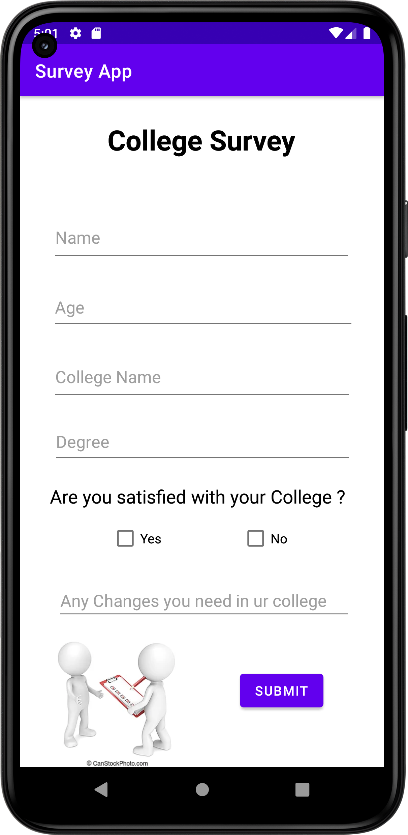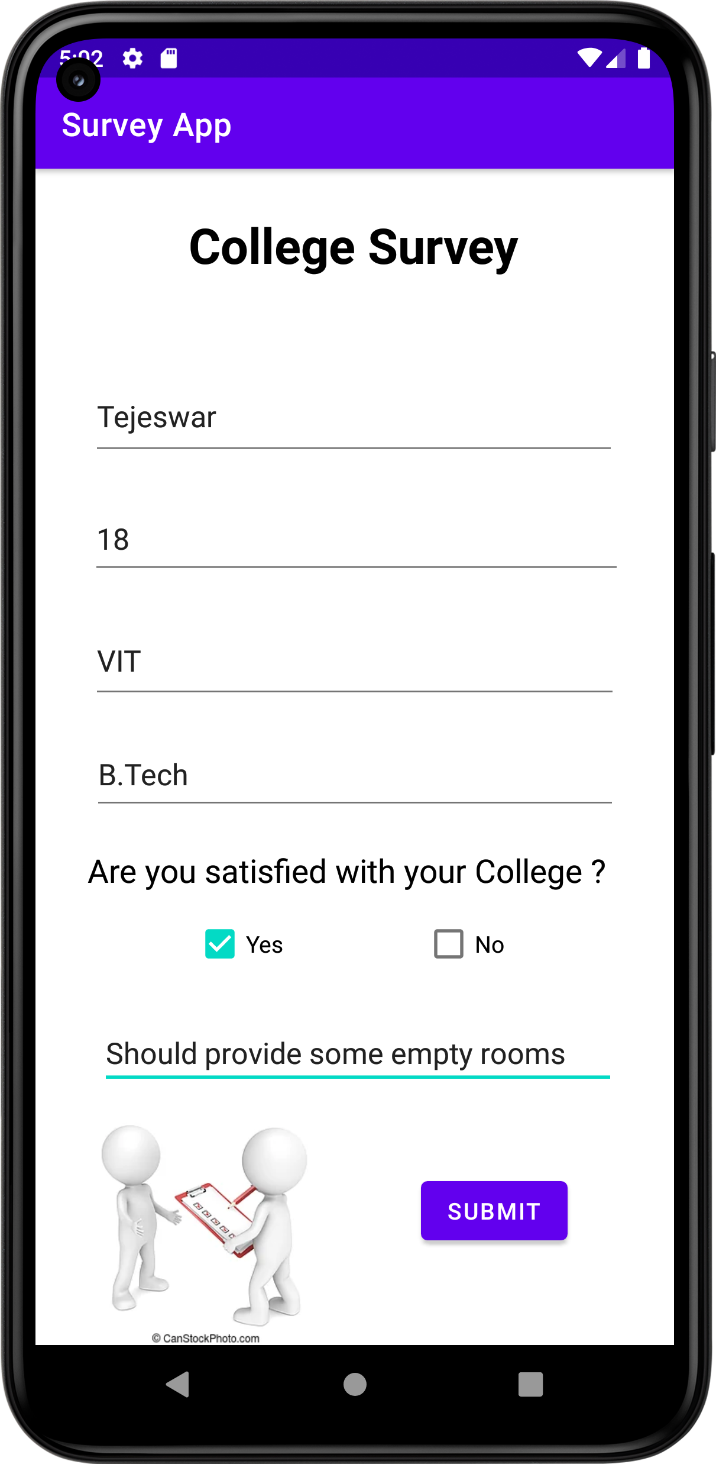

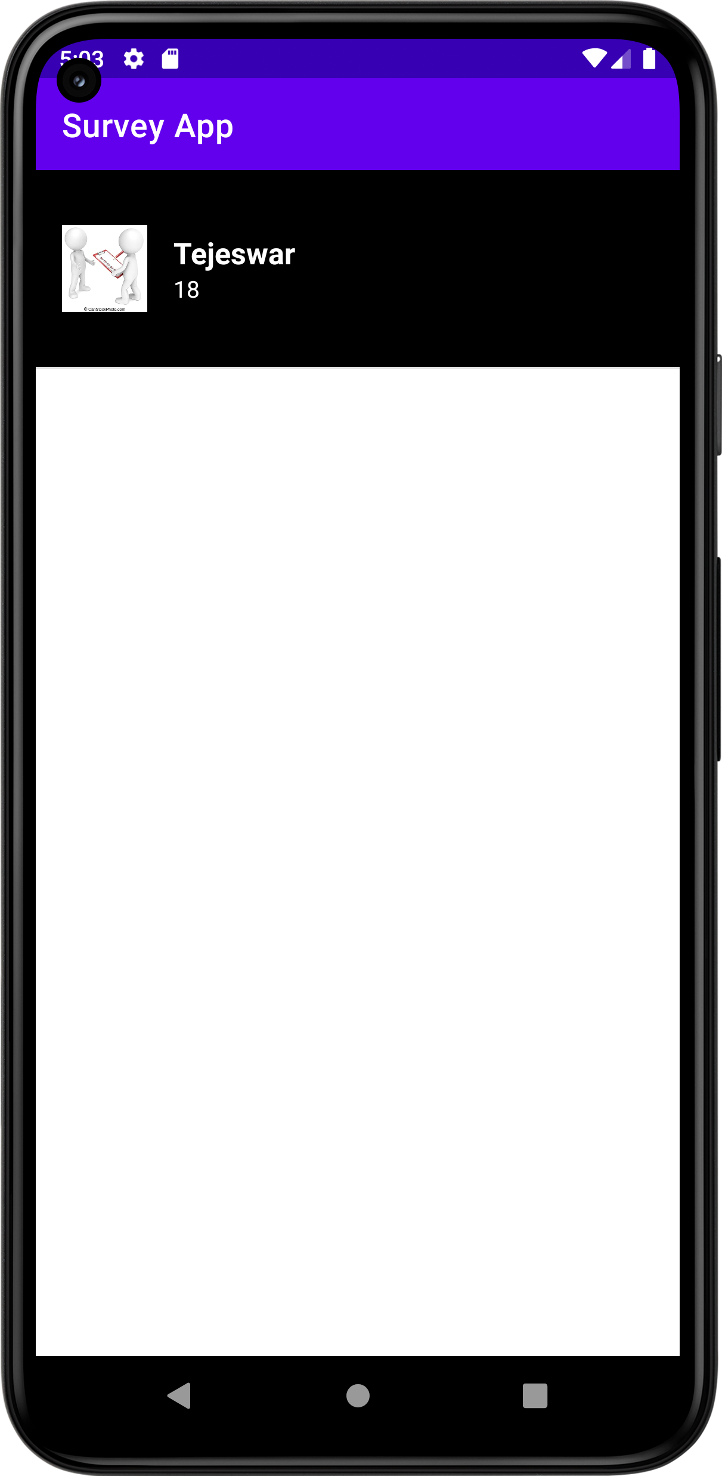

**Layout:**

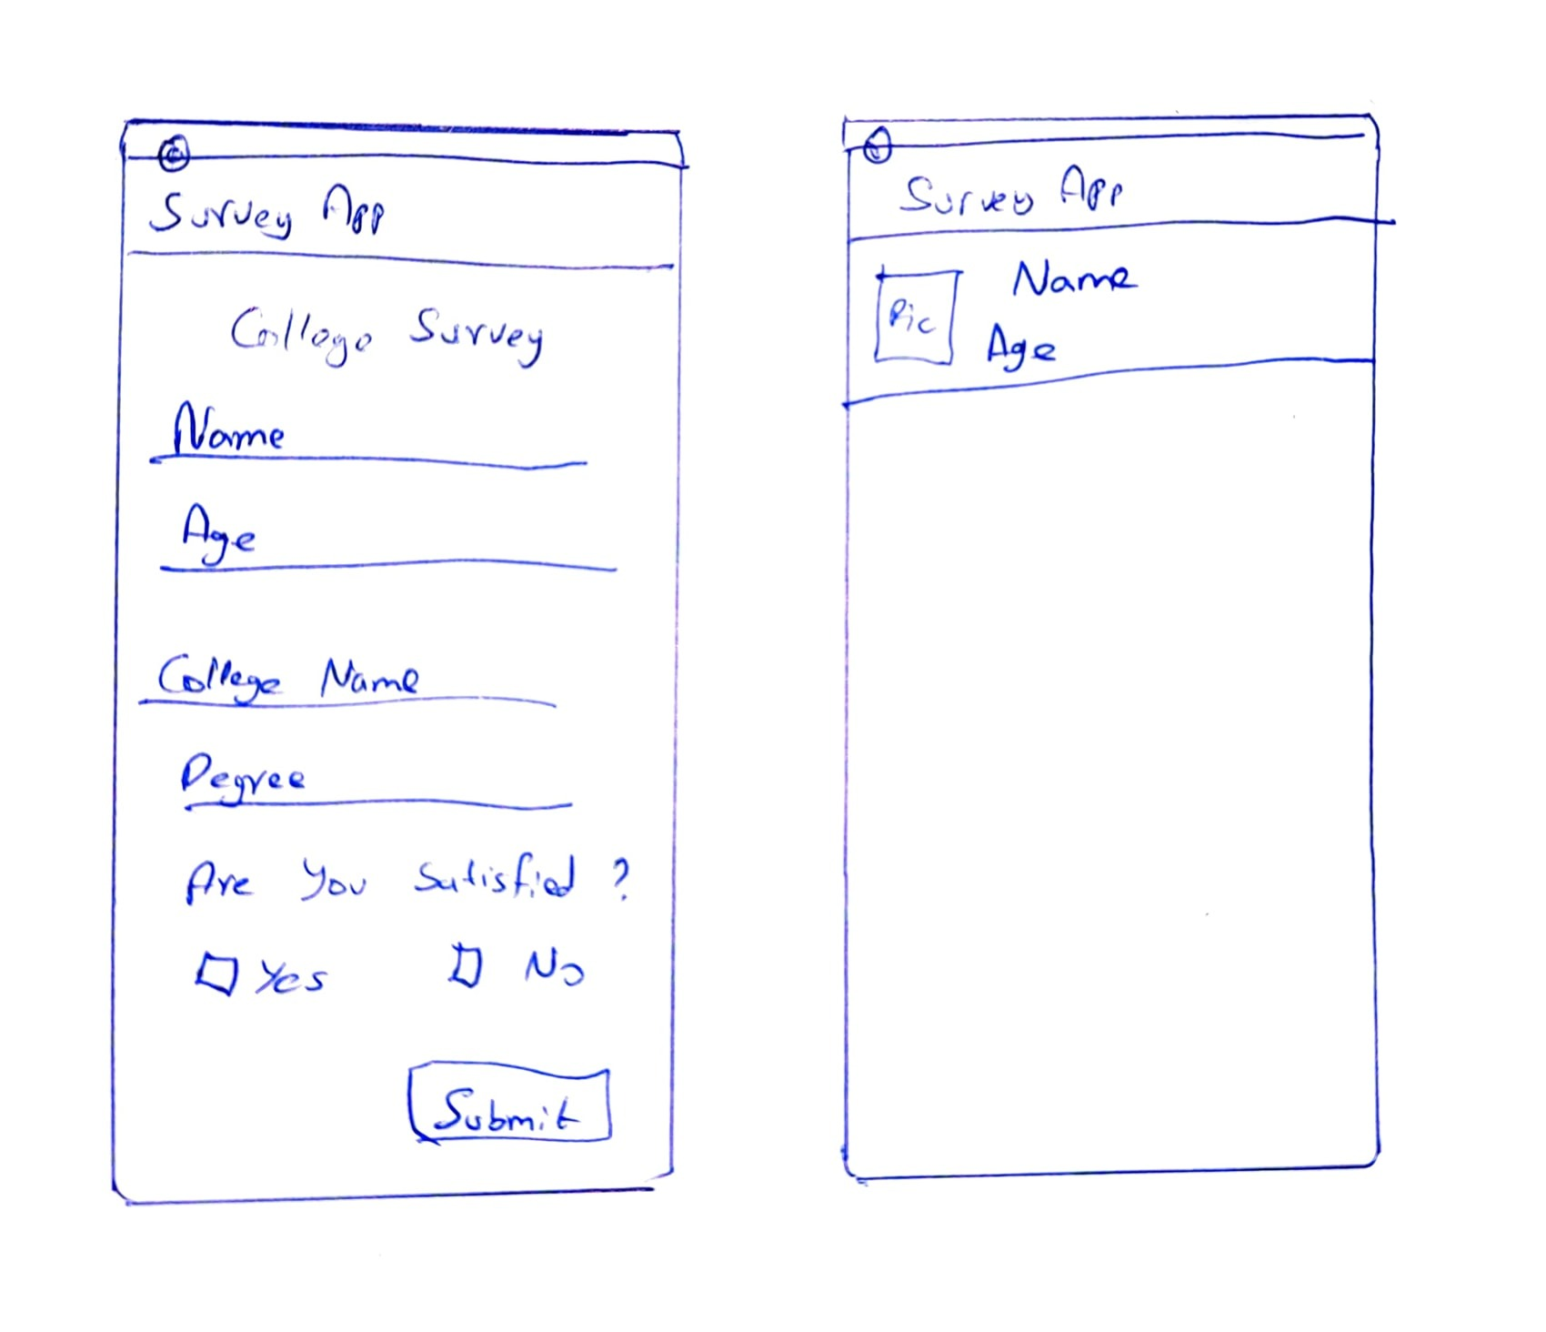

**jUnit5:**

